Game Design Document



Nama anggota:

1. Joel robert justiawan (2101629672)
2. Andreas (2101677601)
3. Septesen (2101689311)

Geogon PolyMetry 3D

**Description**

Player play as sphere shape character that can change shape to other shape such as Cube, Tetrahedron etc.. player have to go through all sort of obstacle and other. The character (SHanpe) go on adventure to travel all around the world.

**Background**

SHanpe finally has been evolved to his three dimensional form after finished the last level. SHanpe has no idea why did he landed in 3D world instead of going back home. Some says that the creator has another assignment, and some says that the creator has to research for the future upcoming projects.

SHanpe is now in 3D! You can move back, forth, side left and right! SHanpe still has famous change shape feature to out of 3 shapes: Sphere, Cube, and Tetrahedron. SHanpe can jump, ride vehicle, interact with items called ItemEffects that does anything from coin to level controls! SHanpe continues his adventure in the next world, finding out things and resolving weird unusual mysteries occured to his life as of now.

**Location**

Based on an unknown island. SHape didn’t know where he was, all that he know is that he is stranded on an island

**Target Audience**

* Teen to Young Adult(13-21) (E 10+)

Our team choose teen and young adult for our game because it fit more to our game. The design isn’t very cartoony. Also the game based on adventure and platforming making it hard for children to play our game. Teen and young adult like challenge and adventure, which make it fit to our game.

**Genre**

* Platformer
* Adventure

We choose platform-Adventure because it is entertaining. As how is the game has been designed to play, such genre appears to match the criteria. Infact, we found many indie devs to enterprise devs nowadays are start to scarce to make platformer for its complexity (specifically 3D platformer like 7th gen game console era e.g.). Other gamers and developers were disappointed by this fact. Therefore, Perkedel step out the feet and make dare statement to resurrect the glory of platformer. Speaking about Adventurer, we also found out that these days that if it is adventurer, things that come out in popular search mostly is RPG (Role playing games) which is commonly top view 2D graphics. That is why 3D. It was rare to see new simple 3D games that was glory in the game console era.

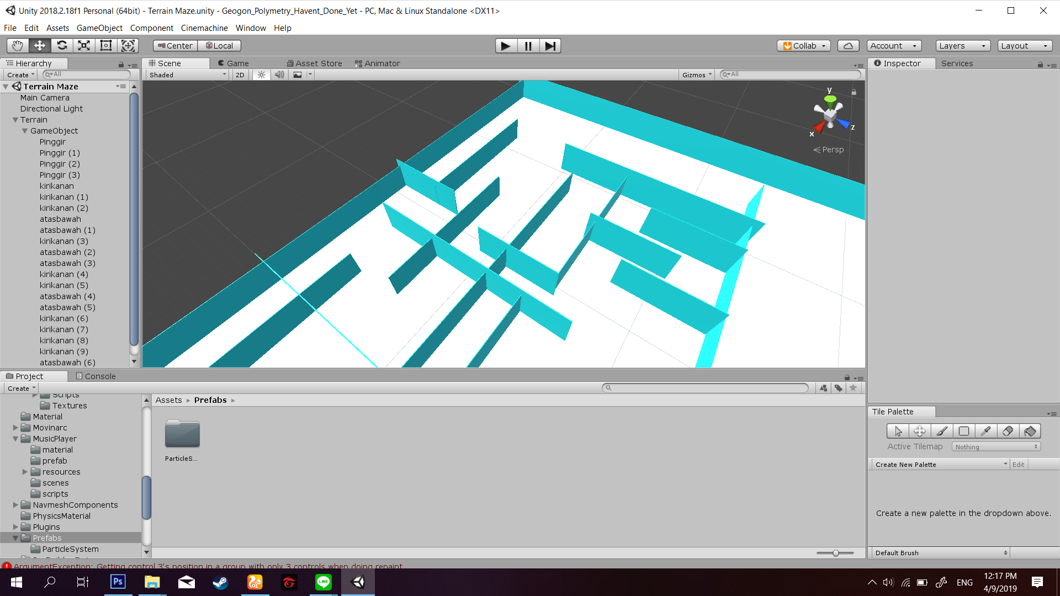

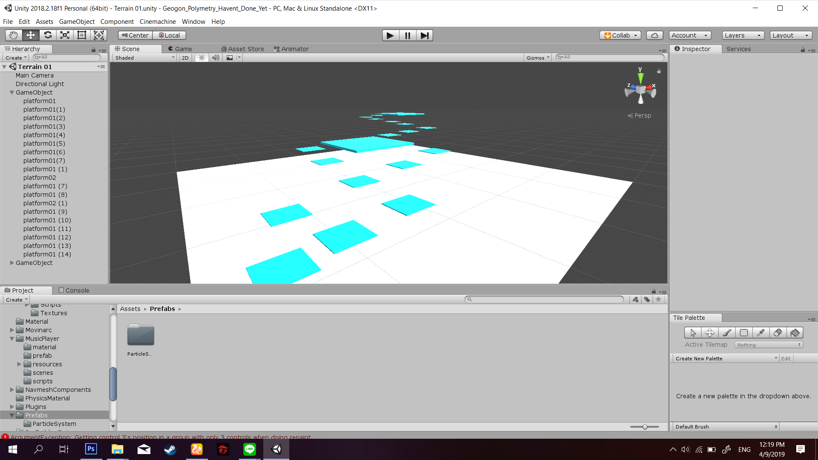

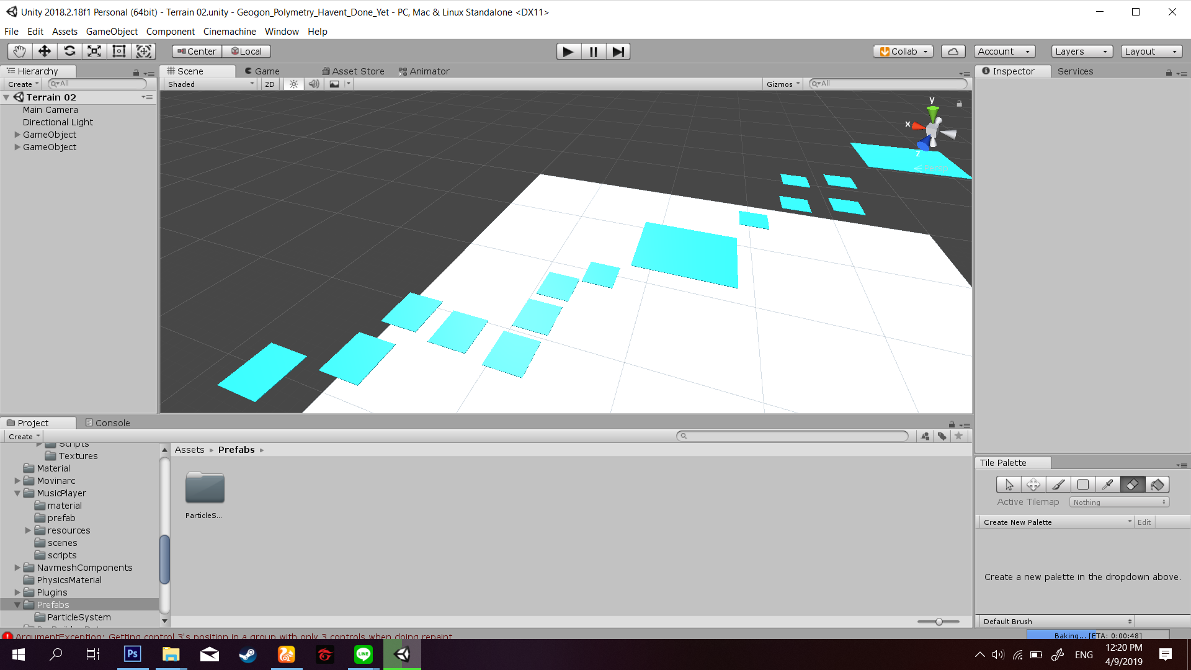

**Target Platform**

* PC
* Mobile

PC and mobile platform is the first media that we use for this game and because PC and mobile platform is the most easiest way to show our game. As we saw everyday life of those teens and young adults, most of such people love to play games to one of them on PC, and Mobile. They like to carry their mobile phone not just to call and chat someone but also to have entertainment. Even some gamers carry a big laptop everyday to be brought at some special events like game party, game contests and more.

**Asset**

* Bola, kubus, dan limas || Character(SHanpe)

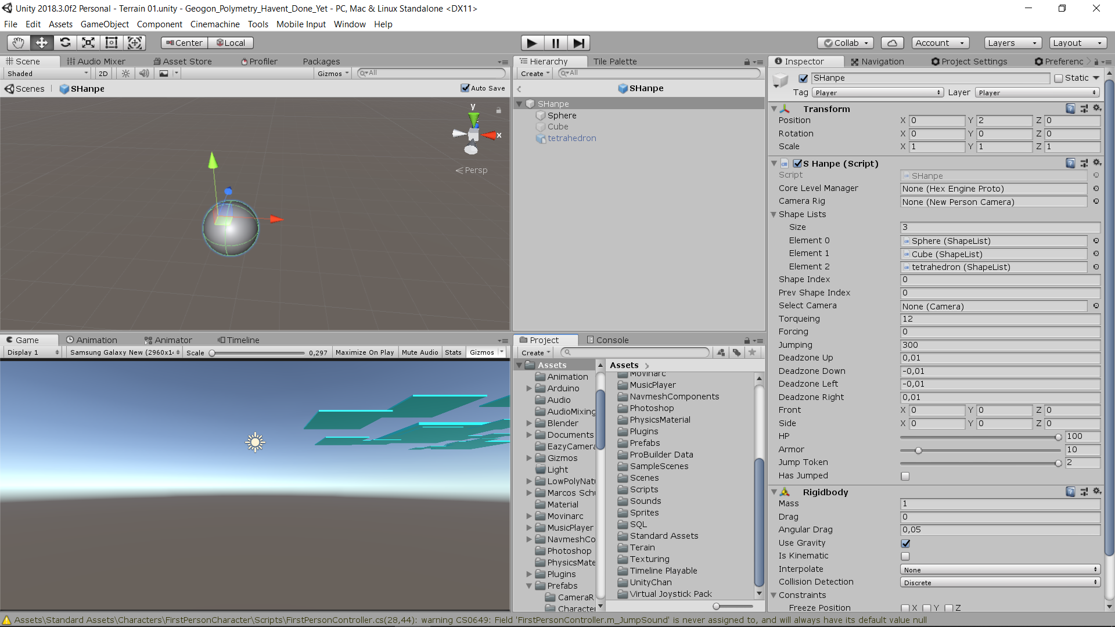

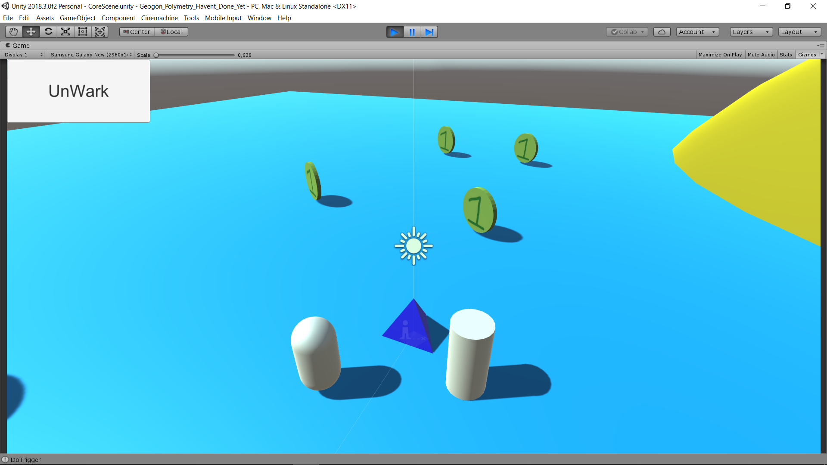

* Capsule || Enemy

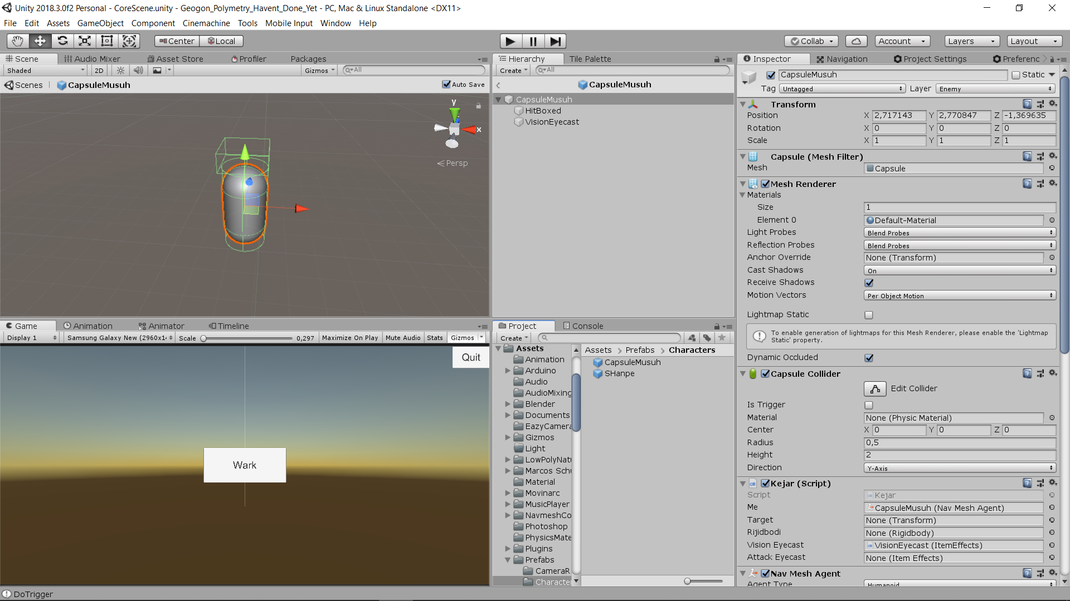

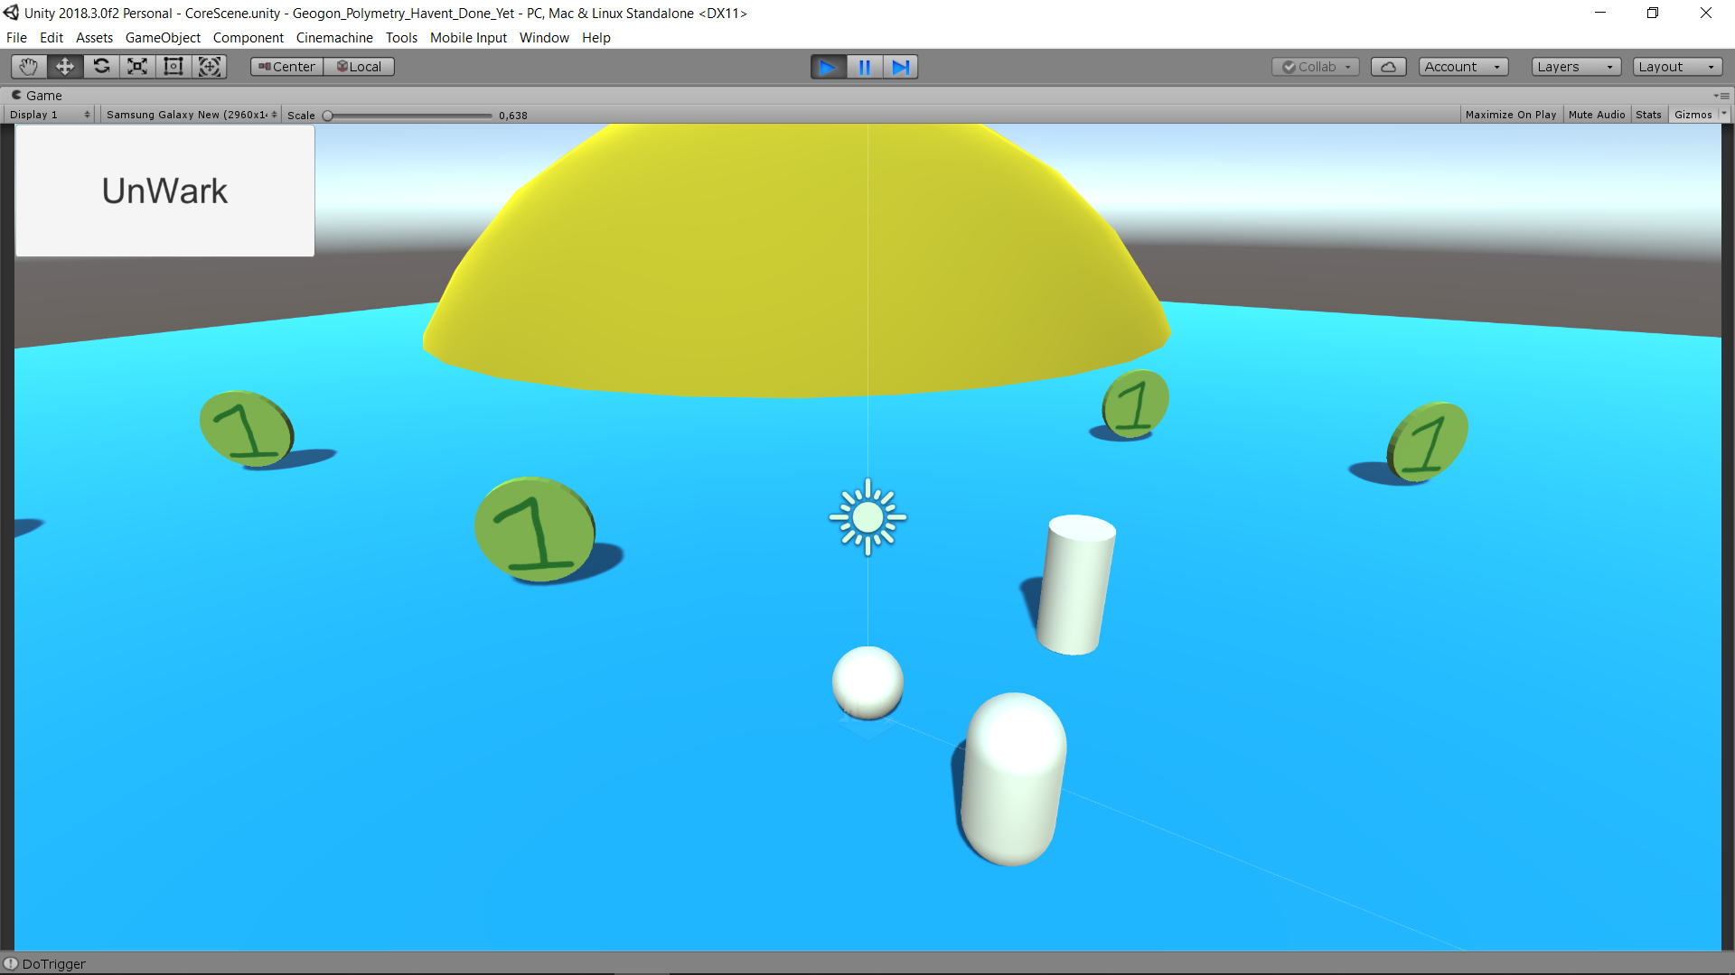

* Flag

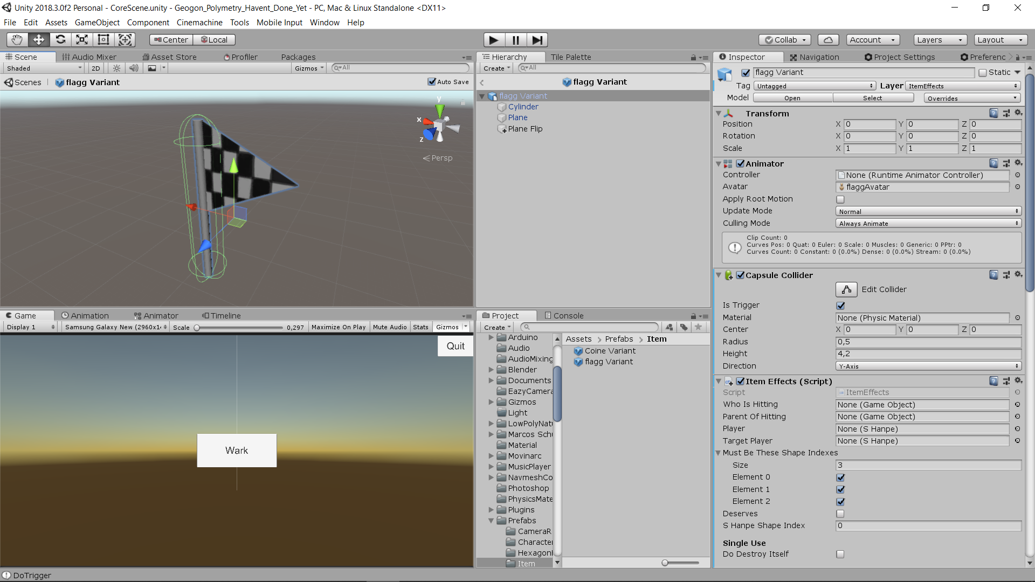

* Coin

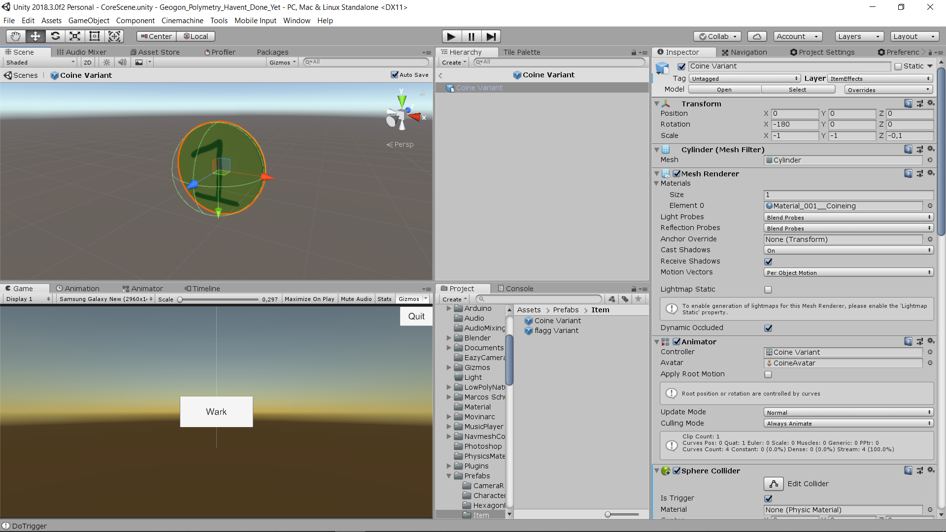



* **Particle**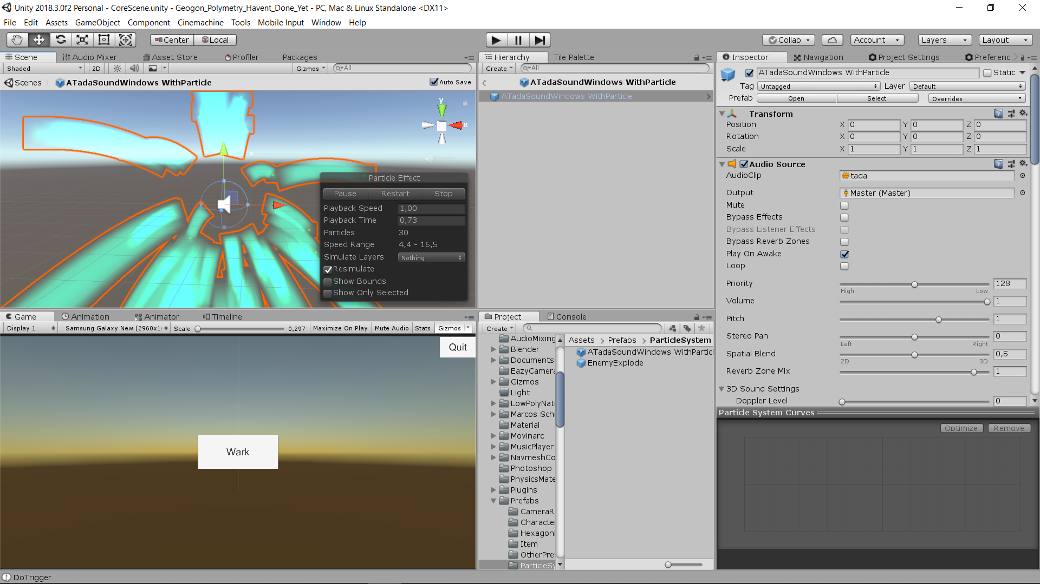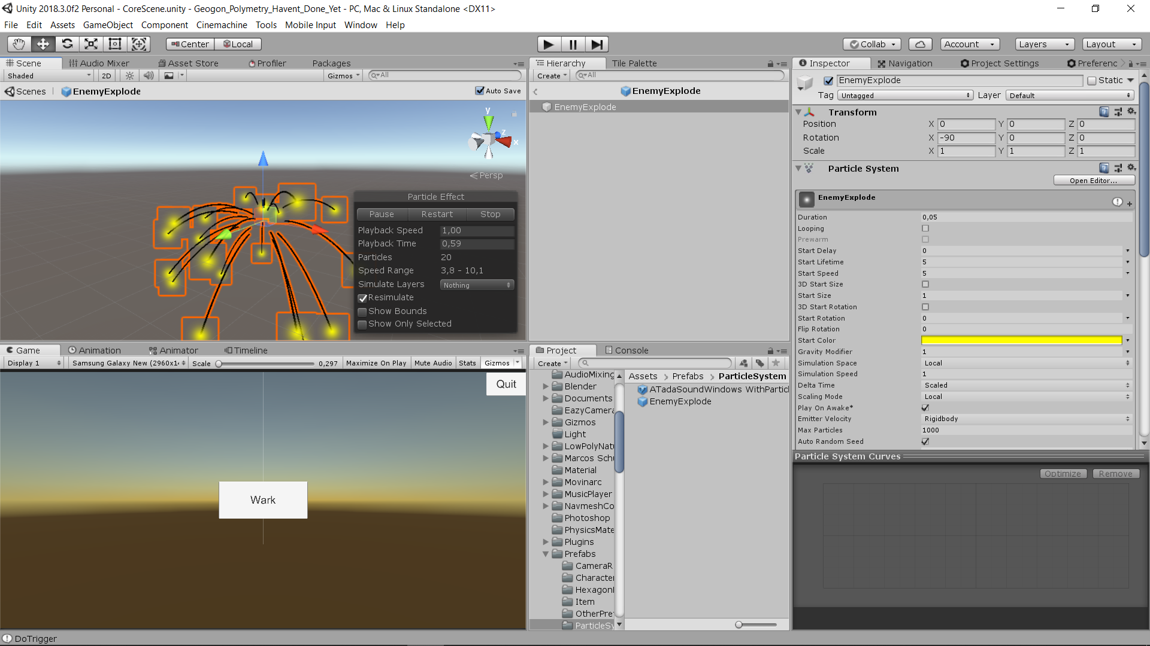

Unity Asset (Montain Terrain) # Optional

<https://bit.ly/GeogonYou1st>

<https://bit.ly/GeogonYou1stSource>

<https://bit.ly/GeogonYou1stCredit>